**How to get list of files from a specific container?** Also, once you have your pipeline ready, you need to create other 2 pipelines to do some variation at dataset and “Filed List” of Metadata Activity.

**Requirements:**

We have list of files in Azure Blob Storage. We need list before further process.

**Solution:**

1. Here our source is Azure Blob Storage.
2. Create a new pipeline as “Lab3_1”
3. Add “Get Metadata” activity
4. On Setting tab of above activity, set suitable dataset (Make sure your dataset pointing to a Specific container and there is no file in dataset) **– (Please in pipeline PL_GETMETADATA_ACTIVITY)**
5. Also set Filed List as below

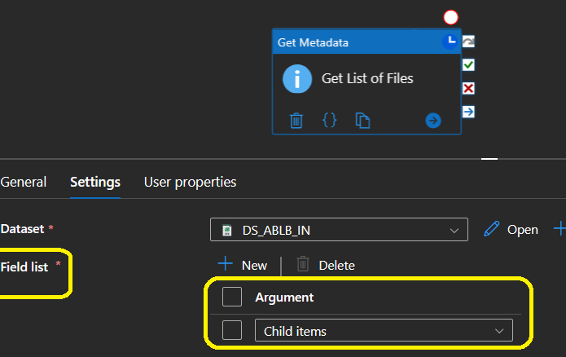

1. Debug Pipeline (Check your storage container 1st and make sure it has more than on1 file.
2. Note – output. It should be something like below based on what data you have in your container

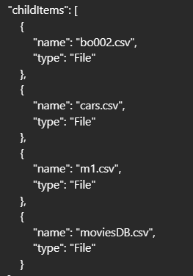

Now try for more alteration using above solution. Note: Make sure, you have created new pipeline every time by just clone existing pipeline and rename it.

1. In just changed in your dataset with a specific file.

Run pipeline and Notes result

1. Now in this version, just changed “field list”. Run pipeline and note down output. It will return either “true” is file exist or false. **(Please see pipeline - PL_GETMETADATA_ACTIVITY_Exist)**

